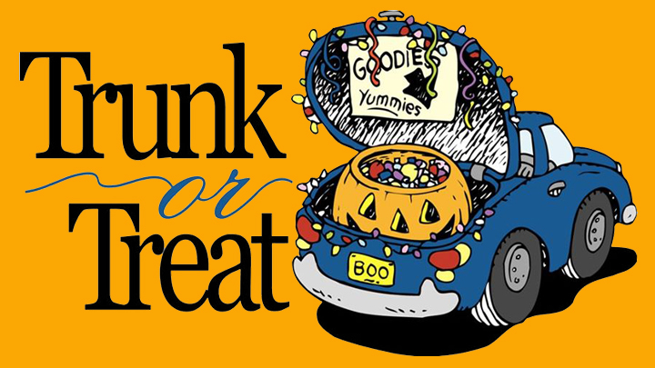

We are very excited about our 2nd Annual Trunk or Treat event!

Come to the Twin Town Little League Fields and Trunk or Treat, have dinner at the food trucks and
listen to the DJ spinning Halloween tunes!

This year will also include:
      - Cupcake decorating table
      - Pop Up Book fair will be open
      - Pumpkin decorating table (please bring your pumpkins from the pumpkin race, pumpkins will not be provided)

Reserve your spot TODAY!!!
Reservations will be accepted now through Monday, Oct. 22nd or until spots are full. We are also looking for donations from our Bell Top bakers for cupcakes, frosting and decorations for the cupcake decorating table
and pumpkin decorating supplies.

Date: Thursday, October 25th (Rain date Monday, October 29th)

Time: 6:00PM – 8:00PM

Price of Admission: 1 bag of candy per child attending (Max 3 bags per family)
There will be a table setup for candy drop off

5:15pm: Check in begins! (Someone will be at the entrance of Twin Town to show you your parking spot)

5:15-5:45pm: Decorate your trunk!

6:00pm: TRUNK OR TREAT begins!
___________________________________________________________________________________________________

Reservation Form
Reservations will be accepted STARTING NOW through Monday, Oct. 22nd

ALL reservations should be turned into your child’s teacher who will then forward it to the PTO mailbox in the Office.

Name________________________________________________ Childs Grade

________ Yes, I would like to reserve 1 spot for the Trunk or Treat

________ Yes, I will donate 1 dozen cupcakes for decorating
________ Yes, I will donate frosting and cupcake decorating supplies
________ Yes, I will donate pumpkin decorating supplies

