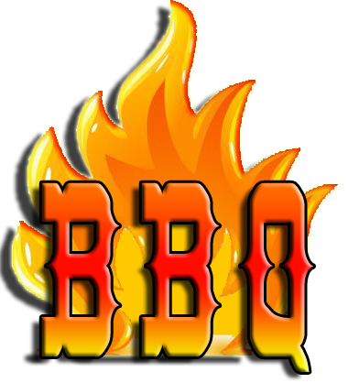
The Bell Top PTO will be hosting a take-out Chicken BBQ

When: October 18, 2018
This is the Day of the Pumpkin Race!

Where: All orders will be grilled fresh that day and available for pick-up from 3PM – 6PM in the Bell Top Parking Lot.

Price per Dinner is $12 and includes Chicken, potatoes and Corn

Tickets will be coming home with each student, but please feel free to print this page, complete the bottom portion and send it in with cash or check made out to the Bell Top PTO by Monday, October 15.

Name: __________________________________________________________________________________
Student Name____________________________________________ Grade:_______________________
Number of Dinners______________________________ Amount Enclosed ______________________

A Portion of the proceeds from all dinners goes directly to the Bell Top PTO

